Lab 4: User-defined PL/SQL Procedures and PL/SQL Packages

1. PL/SQL Procedure
2. Definition of Procedure without Parameters (Header and Body).
3. CREATE OR REPLACE PROCEDURE Display_Message
4. IS
5. today_date      DATE;                           *-- Date Data type*
6. w_hello         VARCHAR2(30) := 'Hello World!'; *-- Character Data type*
7. BEGIN
8. today_date := SYSDATE;
9. dbms_output.put_line('My first message with PL/SQL Procedure: '||w_hello);
10. dbms_output.put_line('Today''s date is ' || today_date);
11. END;

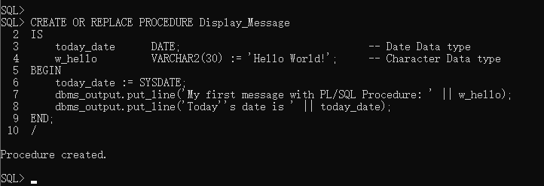

• Call of Procedure without Parameters.

1. DECLARE
2. w_message VARCHAR2(30) := 'Call procedure';
3. BEGIN
4. Display_Message;
5. END;

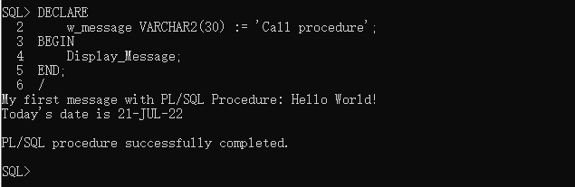

b) Definition of Procedure with Parameters (Header and Body)

Definition of Procedure with Parameters

1. CREATE OR REPLACE PROCEDURE Issue_Billing    *--Body of procedure Issue_Billing*
2. (Prd_Price IN number, Prd_Qty IN number)
3. IS
4. total_price     number(7,2);    *--Number Data type*
5. Fed_Tax         number(5,3) := 0.075;
6. Prv_Tax         number(5,3) := 0.060;
7. BEGIN
8. total_price := (Prd_Price * Prd_Qty)
9. + (Prd_Price * Prd_Qty) * Fed_Tax
10. + (Prd_Price * Prd_Qty) * Prv_Tax;
11. dbms_output.put_line('The Entered Product Price is: ' || Prd_Price);
12. dbms_output.put_line('The Entered Product Quantity is: ' || Prd_Qty);
13. dbms_output.put_line('TheTotal of Billing is: ' || total_price || ' $');
14. END;

Call of Procedure with Parameters

1. DECLARE
2. Product_Price   number(7,2);        *--Number Data type*
3. Product_Qty     number(7);          *--Number Data type*
4. total_price     number(7,2);        *--Number Data type*
5. BEGIN
6. Product_Price := &Prod_Price;
7. Product_Qty := &Prod_Qty;
8. Issue_Billing(Product_Price, Product_Qty);  *--Call*
9. END;

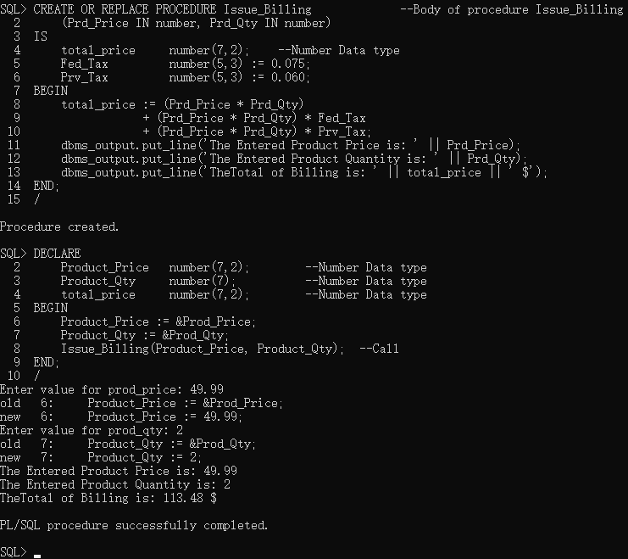



2. PL/SQL Package

a) The general syntax

1. CREATE OR REPLACE PACKAGE BODY BillingPackage
2. AS
3. PROCEDURE Display_Message       *--Body of procedure Display_Message*
4. IS
5. today_date      DATE;
6. w_hello         VARCHAR2(30) := 'Hello World!';
7. BEGIN
8. today_date := SYSDATE;
9. dbms_output.put_line('My first message with PL/SQL Procedure: ' || w_hello);
10. dbms_output.put_line('Today''s date is ' || today_date);
11. END Display_Message;
13. PROCEDURE Issue_Billing         --Body of procedure Issue_Billing
14. (Prd_Price IN number, Prd_Qty IN number)
15. IS
16. total_price     number(7,2);
17. Fed_Tax         number(5,3) := 0.075;
18. Prv_Tax         number(5,3) := 0.060;
19. BEGIN
20. total_price := (Prd_Price * Prd_Qty)
21. + (Prd_Price * Prd_Qty) * Fed_Tax
22. + (Prd_Price * Prd_Qty) * Prv_Tax;
23. dbms_output.put_line('The Entered Product Price is: ' || Prd_Price);
24. dbms_output.put_line('The Entered Product Quantity is: ' || Prd_Qty);
25. dbms_output.put_line('TheTotal of Billing is: ' || total_price || ' $');
26. END Issue_Billing;
27. END BillingPackage;

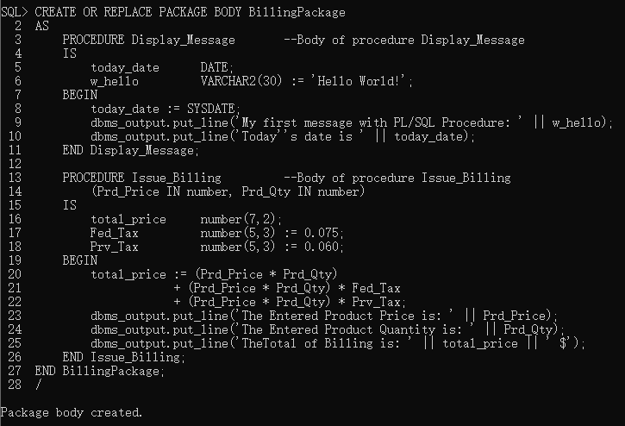

b) Calling procedure and function from package

1. BEGIN
2. BillingPackage.Display_Message;
3. END;

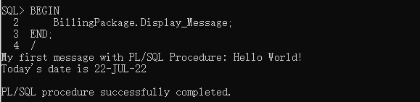

1. BEGIN
2. BillingPackage.Issue_Billing(&price, &qty);
3. END;

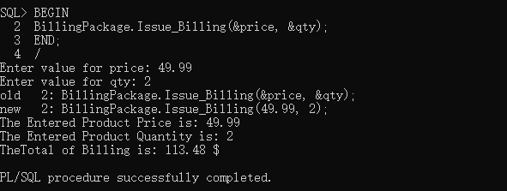

3. Execute the script file Registration.sql (Lab 2) for creating tables of Registration System.

a) Create a Procedure to be named Display_CategoryStudent that accepts one formal parameter(Cat_Stud_ID) to display Category Student description, start date, and end date of givenstudent category id found in CategoryStudent table.

Procedure Display_CategoryStudent

1. CREATE OR REPLACE PROCEDURE Display_CategoryStudent
2. (stud_id in categorystudent.cat_stud_id%TYPE)
3. AS
4. s_start_date categorystudent.cat_start_date%TYPE;
5. s_end_date categorystudent.cat_end_date%TYPE;
6. s_desc categorystudent.cat_stud_desc%TYPE;
7. BEGIN
8. SELECT cat_start_date, cat_end_date, cat_stud_desc
9. INTO s_start_date, s_end_date, s_desc
10. from categorystudent
11. where cat_stud_id=stud_id;
12. dbms_output.put_line('The Category Student description found is : ' || s_desc);
13. dbms_output.put_line('Category Student Date : ' || s_start_date);
14. dbms_output.put_line('Category Student End Date : ' || s_end_date);
15. END Display_CategoryStudent;

Calling Procedure

1. DECLARE
2. category_stud_id number;
3. BEGIN
4. dbms_output.put_line('Enter value for category_stud_id: ');
5. category_stud_id := &category_stud_id;
6. Display_CategoryStudent(category_stud_id);
7. END;

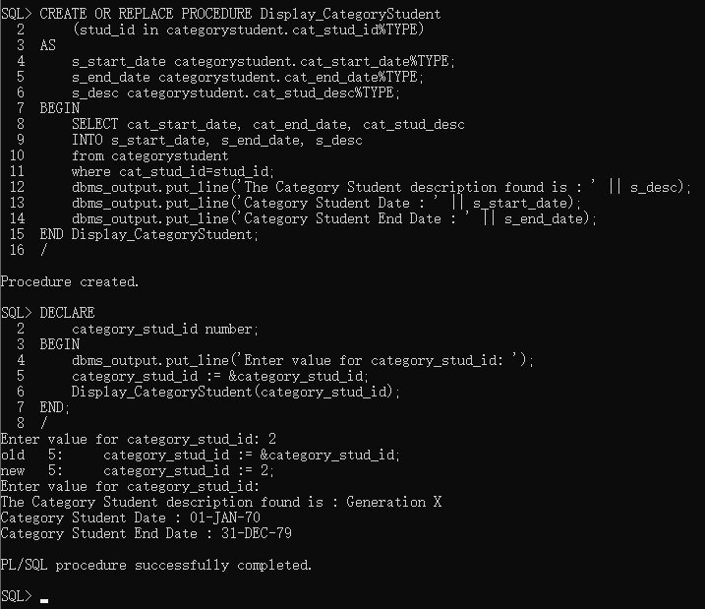

b) Create a Procedure to be named doCalc_Cost_Tuition that accepts three arguments(course_price, num_course, cost_manual) and computes the cost of a tuition (cost_work)according to the following formula:

cost_tuition = (course_price * num_course) + cost_manual

Procedure doCalc_Cost_Tuition

1. CREATE OR REPLACE PROCEDURE doCalc_Cost_Tuition
2. (course_price IN number, num_course IN number,
3. cost_manual IN number,
4. cost_tuition OUT number)
5. AS
6. BEGIN
7. cost_tuition := (course_price * num_course) + cost_manual;
8. END doCalc_Cost_Tuition;

Calling Procedure

1. DECLARE
2. course_price    number;
3. num_course      number;
4. cost_manual     number;
5. cost_tuition    number;
6. BEGIN
7. dbms_output.put_line('Enter value for course_price: ');
8. course_price := &course_price;
9. dbms_output.put_line('Enter value for num_course: ');
10. num_course := &num_course;
11. dbms_output.put_line('Enter value for cost_manual: ');
12. cost_manual := &cost_manual;
14. doCalc_Cost_Tuition(course_price, num_course, cost_manual, cost_tuition);
15. dbms_output.put_line('The Total Cost of Tuition Corresponding to');
16. dbms_output.put_line('Course Price: ' || course_price || '$');
17. dbms_output.put_line('Number of Courses: ' || num_course);
18. dbms_output.put_line('Cost Manual: ' || cost_manual);
19. dbms_output.put_line('is: ' || cost_tuition || '$');
20. END;

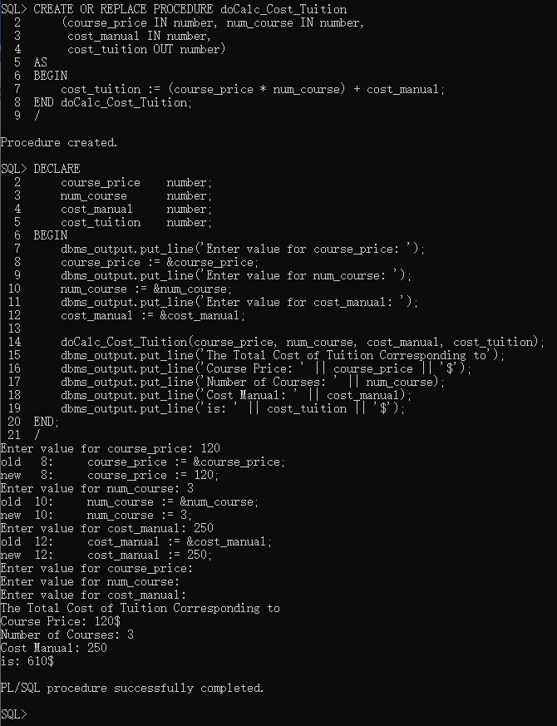

1. Create a package to be named RegistrationPackage that contains all previous procedures(Display_CategoryStudent, doCalc_Cost_Tuition)
2. PL/SQL Package

4. Review Questions

A. Write necessary PL/SQL statements to create the following components:

1. A heading of PL/SQL procedure named **Calculate_ProjectContribution** with twoparameters **Project_Name** of type **varchar2(30)** and **Project_SDate** of type **Date().**

2. A PL/SQL package specification named **ProjectPackage** which contains the namedprocedure **Calculate_ProjectContribution**.

3. A variable cursor named **CategoryEmployee_row** of type **CategoryEmployee_cursor**to reference a given record.

4. Declare a cursor named **course_cursor** that self-join a table **course** (of **Registration**script) to display **course names** and its **course pre-requisites**.

5. Declare variable named **vsalary** of the same type as field **Salary** from **employee** table.

6. A prompt statement to input a value of salary assigned to previous variable **vsalary**.

7. Declare a cursor named **studentgrade_cursor** that displays student information (s_last,s_first, s_class, birthday) and their grades (from **Registration** script).

8. Declare a cursor named **DeptFacultyStudent_cursor** that displays departmentinformation (DeptId, DeptName, Location) and its faculty members along with theirsupervised students (from **Registration** script).

B. Multiple choice (only one answer per question is valid)

1. The user-defined PL/SQL package is used to

a. reduce the number of statements b. insert SQL query

c. enhance reusability d. show error

2. An advantage of declaring user-defined PL/SQL procedure is to

a. create modular program b. fasten the program execution

c. ease the debugging of program d. all of the above

3. A user-defined PL/SQL procedure refers to

a. query tables b. action to be executed

c. using cursors d. fields to be used

4. A user-defined PL/SQL package may contain _____

a. only one procedure b. at least two procedures

c. many procedures d. only scalar variables

5. An explicit cursor is used to fetch _____record(s)

a. one b. at least two

c. variable d. multiple

6. An anchored variable uses key word _____

a. TYPE b. CURSOR

c. ROWTYPE d. FETCH

**3. Execute the script file *Registration.sql* (Lab 2) for creating tables of Registration System.**